Registration Form

XIV Iberic Meeting of Electrochemestry & XVII Meeting of the Portuguese Electrochemical Society

I would like to book my reservation in Hotel CS Madeira Atlantic Resort & Sea SPA, as follows:

Surname: |  |  | First Name:
Address:
Country: |  | City: |  | Zip Code:
Phone Number: |  |  | Fax Number:
E-mail address:
Company/ Institution:
Department: |  |  | Position:
Arrival Date: | Arrival Time: |  | Departure Date |  | Departure Time:
Flight Number: |  |  | Flight Number:

Conference Delegate Package from the 11th to the 14th April 2012

1. Conference Delegate Package: includes 03 night’s accommodation in a Room with Ocean View, private balcony and Buffet Breakfast; 03 days Conference including mineral water and 05 Coffee-Breaks with biscuits; 03 Light Buffet Lunches including juices, mineral water and american coffee.

  - Double room, single occupancy: Euro 388.50 per room, per package
  - Double room, double occupancy (both delegates): Euro 531.00 per room, per package
  - Double room, double occupancy (one delegate and one non delegate, including 03 lunches for the non delegate): Euro 519.00 per room, per package
1.4 Double room, double occupancy (one delegate and one non delegate): Euro 436.50 per room, per package

2. Accommodation for Extra Nights: Please inform the extra nights: ________________________________

Extra Nights in Double room, single occupancy: Euro 98.00 per room, per day
Extra Nights in a Double room, double occupancy: Euro 114.00 per room, per day

Prices above mentioned are per package and include legal taxes, VAT and Buffet Breakfast

Total Cost for my Booking: Euro ___________________________

Room reservation will be valid, only when the Hotel receives the deposit due, to secure the reservation (please see below method of payment).

Method of Payment

. Credit Card
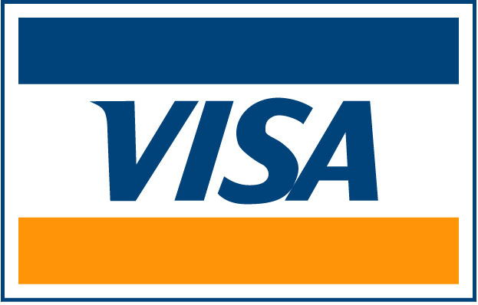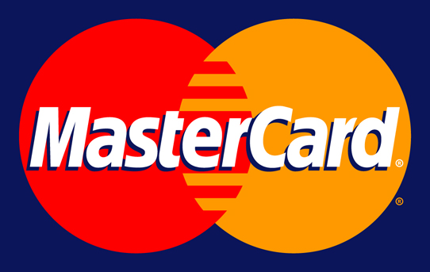
Other:

Name Card: _________________________________________________________________
_ | _ | _ | _ |  | _ | _ | _ | _ |  | _ | _ | _ | _ |  | _ | _ | _ | _

Card Number:

_ | _ | _ | _

Security Code:

Expiry Date: _________________

I authorize CS Madeira Atlantic Resort & Sea SPA to debit in my credit card a total value of: Euro __________

OR

. Bank Tranfer (Please send a copy by fax or e-mail):

Banco Popular – Titular: Carlos Saraiva Madeira Exploração Turística – IBAN: PT50 0046 0392 0060 0138 7180 9 – BIC: CRBNPTPL – NIB: 0046 0392 00600138718 09

.Invoice/ Receipt (in name of): ____________________________________________VAT Number: _______________

Address: __________________________________________________________________________________________

City:__________________________ Zip: _________________ Country: ______________________________________

________________________________ , _______________________________________________________________
(City) (Day, Month, Year)

__________________________________________________________________________________________________
(Signature)

Cancellations Deadlines

•Cancellations made before the 20th March 2012: 50% of the total of your reservation will be charged
•Cancellations made from the 20th March 2012 onwards or no-shows: 90% of total reservation will be applied.

Special Requests: _____________________________________________________________________________

